**Top 11 best hamstring exercises to follow!**

Exercise is one of the most important requirements for keeping a person healthy and fit. Every person has a different fitness regime. Some get engrossed in sports while others prefer to go to the gym. In the gym, people mostly aim to get a full-body, balanced workout. However, while performing the specific workout, we often neglect our hamstrings. It is a common mistake that most people make. There is also a common misconception that getting a burn in the thighs at the end of your exercise automatically coincides with your hamstrings strengthening. Specific exercises help you achieve hamstring fitness. Here is a list of the **best hamstring exercises** to follow -

* **Clean Deadlift**

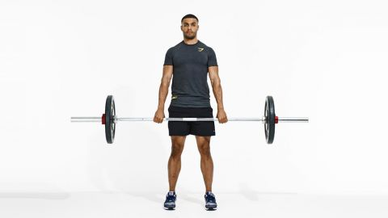

First, in the list of hamstring exercises is the "clean deadlift." It slightly differs from the usual or conventional deadlift version. In the regular deadlift, more pressure is exerted on the lower-ack. However, in the clean deadlift, the pressure is exerted on your hamstrings. Your buttock will be lower, and the area of your arms will get widened. In this exercise, your shoulders will be moved forward, and your shoulder blades will be forced back. Lats, the most significant muscle in your lower back, will be needed to lift the barbell and bring it closer to the body. Usually, a barbell with a lower weight than your usual one is recommended.

<https://www.bodybuilding.com/content/bodybuildingcoms-10-highest-rated-hamstring-exercises.html>

* **Romanian deadlift**

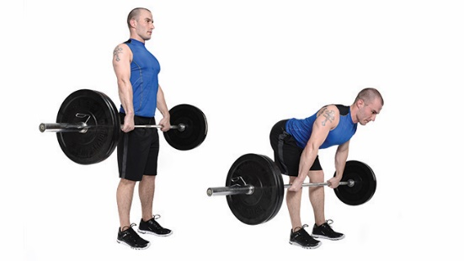

This technique is usually recommended for people who have undergone advanced training. Even though it is called "Romanian deadlift," it is considered to be a "stiff-legged deadlift." The reason being that while performing this exercise, your knees have to bend the entire time slightly. In this exercise, you will have bend around your hips, pushing your shoulders forward. Some people may deliberately round their backs to stretch and train their erector spinal muscles. But this technique can be tricky to perform. Hence, it is restricted to those with advanced training.

<https://www.bodybuilding.com/content/bodybuildingcoms-10-highest-rated-hamstring-exercises.html>

* **Kettlebell one-legged deadlift**

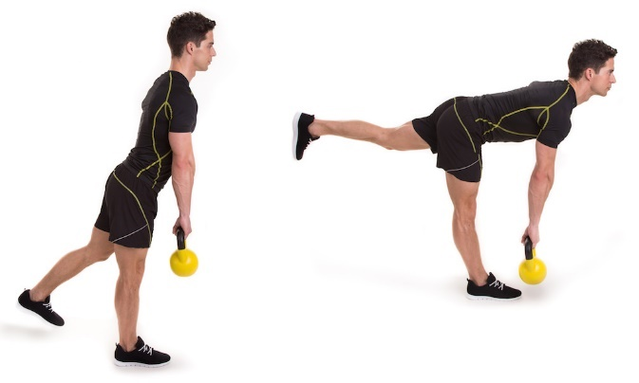

This hamstring exercise is quite different from the rest. The uniqueness of this posture lies in the overall posture of the body. The body's upper body is kept unilateral to reduce the load on the lower-ack. It still fully stretches and trains the hamstrings. Often, people tend to round the spine instead of keeping it parallel. This is one of the biggest mistakes committed by people while performing this exercise. Make sure to keep your back straight and parallel to the ground. The entire body should also be kept stiff and rigid while rotating around the hip. This provides ample training to your hamstrings.

<https://www.bodybuilding.com/content/bodybuildingcoms-10-highest-rated-hamstring-exercises.html>

* **Power snatch**

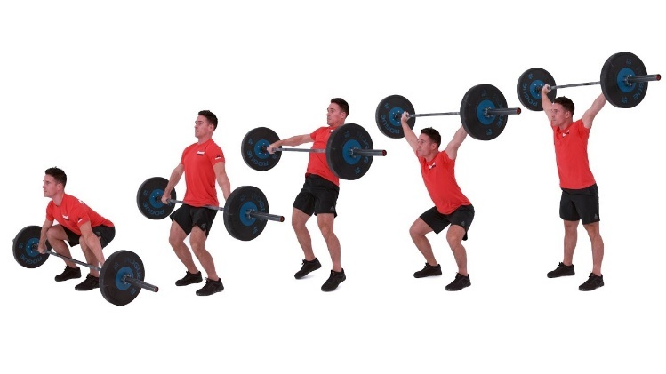

The snatch is predominantly a full-body movement. However, while lifting the barbell with an upward acceleration, the entire body relies on your hamstrings. The power with which you lift the bell solely depends on the strength of your hamstrings. A full snatch is very difficult to perform and requires excessive training. But the power snatch can be achieved by most people. In this exercise, you lift the barbell over your squatted knees. And then lift the barbell with the strength of your hamstrings. This exercise is widely useful for your hamstrings since it contains two components – the deficit deadlift and the Romanian Deadlift. Both these components are excellent at stretching your hamstrings.

<https://www.bodybuilding.com/content/bodybuildingcoms-10-highest-rated-hamstring-exercises.html>

* **Floor-glut ham raise**

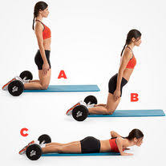

The floor-glut ham raise isn’t the most preferred of all the ham raise versions. Moreover, limited advantage and stretching can be received by using the floor. But this exercise can provide you with maximum flexion in case you prefer the floor for your exercises. This exercise can be tough to master at first. It requires immense strength, body balance, and flexibility. Hence, initially, you can take the help of a training partner, a band, or a push-off. This will reduce the difficulty of the exercise to a particular exercise. But like others, this exercise can train your hamstrings and increase their power.

<https://www.bodybuilding.com/content/bodybuildingcoms-10-highest-rated-hamstring-exercises.html>

* **Hex-bar deadlift**

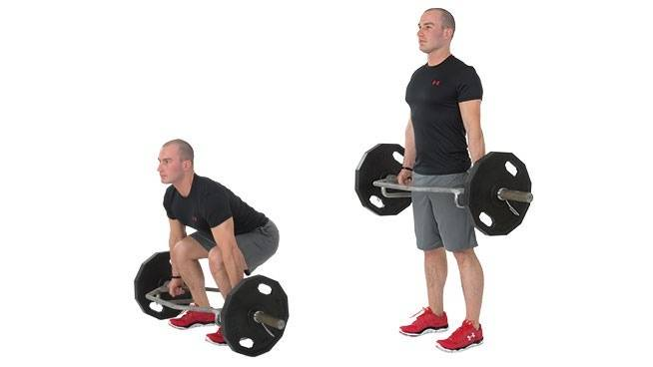

There are various types of deadlifts. Each deadlift has a specific area to strengthen and train. The hex-bar deadlift is the best exercise for your lower body. It reduces the stress on your upper body by providing a neutral grip on the barbell. In this way, you can increase the weight of your barbell and challenge your lower body. In this exercise, Lower your body with your shoulder-width apart. Lift the hex bar, maintain a firm grip, and relax your upper body as much as you can. Tighten your glutes as much as you can. Afterward, slowly lower your body and place the hex bar while pushing your butt behind.

<https://www.menshealth.com/fitness/a26786932/best-hamstring-workouts/>

* **Glute bridge**

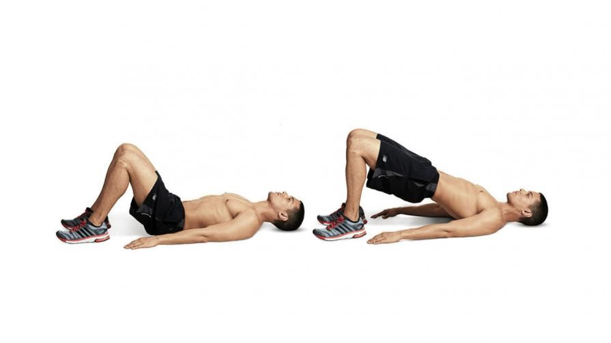

This particular hamstring exercise is widespread and useful. It is easy enough to be performed by anyone and is helpful to strengthen any one part of your body. The strengthening depends on which muscle you concentrate your strength on and which muscle you relax. All you have to do is lie flat on your back. Force your feet or heels into the ground. Slowly lift your torso and thighs. Extend your hips until your thighs are in sync with your torso. Remain in that position for a few seconds and try to maintain a steady posture. Slowly, retract and retain your original position. Performing this exercise a few times can stretch your hamstrings considerably.

<https://www.menshealth.com/fitness/a26786932/best-hamstring-workouts/>

* **Barbell hip-thrust**

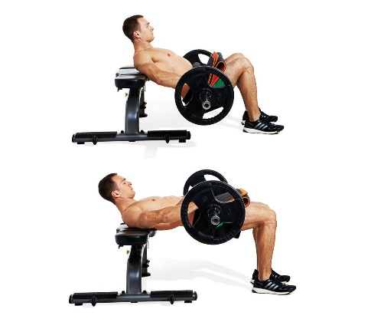

<https://www.menshealth.com/fitness/a26786932/best-hamstring-workouts/>

The barbell hip thrust is similar to the average barbell thrust. But in this exercise, an extra load is added. This increases the difficulty of the hip extension. The increased load will also challenge your buttocks. In this exercise, you are required to sit on the floor and rest your shoulders against a sturdy bench. The barbell should be placed across the front of your hips. Get a stable grip on the barbell. Squeeze your buttocks to lift your hips above the ground. Raise the barbell as you lift off the ground. Make sure to keep your chain tucked to maintain a proper ribcage posture. Raise your body until your torso, and your thighs are in a straight line. Remain in the position for a few seconds before retracting.

* **Swiss ball leg curl**

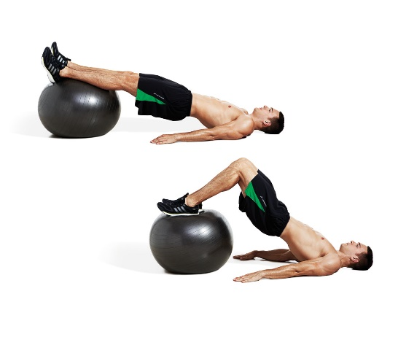

This is the most conventional form of leg curl performed by most. This exercise is specially made to challenge your glute and hamstring instability. This doesn't require any extra load. Gravity and your upper body will naturally create the load. To perform this exercise, lie flat on the ground with your feet placed firmly on the swiss ball. You will need to learn how to balance and control this swiss ball. Tighten your core and bring your heels as close as possible by bending your knees. Pause for a few seconds and then lay your feet flat on the swiss ball. Repeat this a few times to gain maximum stability over your lower body.

<https://www.menshealth.com/fitness/a26786932/best-hamstring-workouts/>

* **Reverse sled pulls**

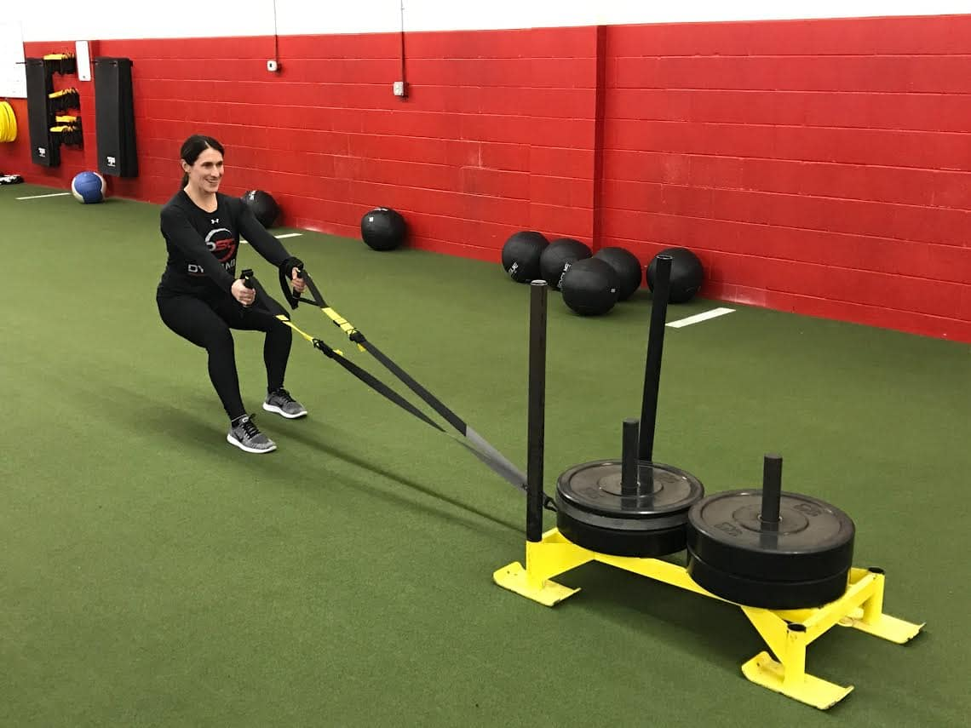

It is a common understanding that driving the sled will train and challenge your quadriceps. But dragging the sled backward will require the strength of your hamstrings. This exercise can be used for training and improving the strength of your hamstrings. You are placing your hands in the same position and pulling on the sled while decelerating. You can perform this exercise by attaching a strap to the sled and getting a firm grip over the sled. Ensure that your chest is facing the sled. Lean your body back, sit in the ideal athletic position, and create tension in the sled. Extending your hands, pull the sled while slowing moving back. Performing this exercise frequently can increase your hamstring power and strength.

<https://www.menshealth.com/fitness/a26786932/best-hamstring-workouts/>

* **Cardio row**

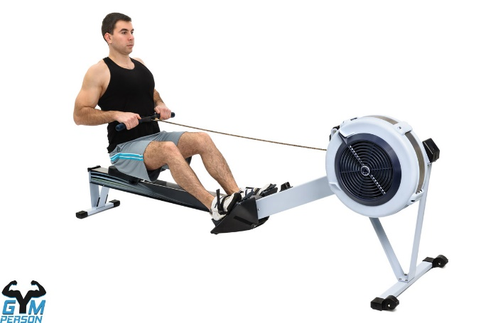

This cardio workout is known to increase your heart rate. But it also trains and strengthens your glutes and hamstrings. This strengthening depends entirely on your rowing power. If you row powerfully, your glutes and hamstrings will get strengthened even further. This cardio exercise needs to be done correctly. If you row correctly, the exercise will mimic a deadlift and barbell row. The only difference being the change of plane. In your cardio rower, sit and bend your knees. Get a firm grip, bend backward, and push handle towards your lower chest. Do these multiple times to get the movement right, and the purpose served. By frequently doing the cardio row, you will easily gain a firm hand and efficiency on this exercise.

<https://www.menshealth.com/fitness/a26786932/best-hamstring-workouts/>

**Conclusion –**

All the exercises, as mentioned above, provide a good workout to your hamstrings. But few of these exercises should be done under the guidance of a trainer or a professional. Certain exercises are only meant for people who have a lot of experience. Hence, before following any exercise, it is important to take certain precautions.

A fitness regime depends entirely on the person’s requirements. Hence, before performing any of these exercises, you need to decide what kind of workout are you aiming for. Also, it is important to not go overboard on the very first day. Fitness is all about maintaining consistency and taking baby-steps. Performing rigorous exercise on the very first day might lead to certain mishaps.